AL AIN UNIVERSITY
College of Engineering (CoE)
Mobile Application Development
0102483
Lab Assessment 1
Shopping Assistant
Fall 2026/2027
Due Date: 11 November 2026
Student ID
Student Name | Aiham Qusai Altujjar

Question | Course Learning  Outcomes | Total Mark | Student Mark
1 | 1, 2, 3 | 7
Total 7 marks

Lab Assessment 1 Shopping Assistant
0102483 Mobile Application Development | Fall 2026/2027 | Total 7 marks | Individual submission
Develop a Shopping Assistant that provides a basic calculator and a bill calculator using Kotlin, XML, Fragments, and Jetpack Navigation. The bill calculator must support multiple items and open a separate Bill Summary screen. Provide a single pane phone layout and a dual pane layout for wide screens.

Learning Outcomes
Outcome | Description
CLO1 | Describe the fundamentals of mobile application development.
CLO2 | Build effective user interfaces for mobile applications.
CLO3 | Write Kotlin programs as part of an Android mobile application.

Application Flow
Phone: Home → Calculator or Bill Calculator → Bill Summary after Calculate Bill. Back to Items returns from the summary to the existing bill. Home returns to the tool list.
Wide screen: the tool list remains on the left. The right pane displays Home instructions, Calculator, Bill Calculator, or Bill Summary. Use Jetpack Navigation to change the content pane.

Development Scope
Use the Activity, Fragment, XML layout, event handling, and navigation techniques covered in class. The tool list may use Buttons or clickable TextViews. Use local in-memory item data; database, internet service, login, RecyclerView, and Navigation Drawer are not required. A TableLayout with TableRows is suitable for the item list and bill.

Functional Requirements
ID | Requirement
L1 | Create a Shopping Assistant using one Activity, Kotlin, XML Views, Fragments, and Jetpack Navigation. Home must provide Calculator and Bill Calculator choices. Do not use a Navigation Drawer.
L2 | Provide a default phone layout and a layout-w600dp variant. On a wide screen, keep the tool list on the left while Home instructions, Calculator, Bill Calculator, or Bill Summary are displayed on the right. On a phone, show one destination at a time.
L3 | Calculator must accept two signed decimal numbers and provide addition, subtraction, multiplication, and division. Display the selected operation name and its result to two decimal places, for example Result of summation: 27.00. Clear must reset the inputs, errors, and result.
L4 | Reject missing or nonnumeric calculator inputs. Division by zero must show a clear message without crashing or retaining a successful result. Negative numbers and valid decimal inputs must be accepted.
L5 | Bill Calculator must contain Item name, Item unit price (AED), Quantity, and an Add Item button. Each successful click must add one row to a table with Item, Unit price, and Quantity columns, then clear the entry fields for the next item. Support multiple items.
L6 | Validate each item before adding it: the name must not be blank, unit price must be a positive number, and quantity must be a positive whole number. Invalid entries must not add a row. Calculate Bill must reject an empty item list. If entry fields contain an item not yet added, request Add Item or clearing those fields before calculating.

Bill Summary and Navigation Requirements
ID | Requirement
L7 | Provide independent Apply 10% discount and Apply 5% tax CheckBoxes. Calculate the subtotal from all added items. Apply the discount to the subtotal, then apply tax to the amount after discount. Both options must also work independently.
L8 | Calculate Bill must open a separate Bill Summary Fragment through Jetpack Navigation. Pass the added item details and selected options to it. Display Item, Unit price, Quantity, and Line total for every item, followed by Subtotal, Discount, Tax, and Final Total in AED to two decimal places. Make the final total visually clear.
L9 | Back to Items, toolbar Up, and system Back from Bill Summary must return to the existing Bill Calculator with its added items and selected options retained. Clear on Bill Calculator must remove all item rows, empty the inputs, clear errors, uncheck both options, and reset feedback.
L10 | Home on either tool or Bill Summary must return to Home. Back from a tool returns Home; Back from Home exits. Repeated tool selections must not build a stack of duplicate screens. Keep the wide-screen tool list visible during navigation.
L11 | Write a short explanation of the navigation host, controller, graph, layouts, and passing bill details between Fragments. Submit the project ZIP and completed Word report as specified below.

Bill Calculation Order
Line total = unit price * quantity.
Subtotal = sum of all added item line totals.
Discount = subtotal * 0.10 when selected; otherwise 0.
Amount after discount = subtotal - discount.
Tax = amount after discount * 0.05 when selected; otherwise 0.
Final Total = amount after discount + tax.
Use unrounded values for the calculations and format the displayed amounts to two decimal places. Keep the two CheckBoxes independent. Reject invalid or excessively large values rather than displaying a successful result.

Required Test Cases
Case | Input or action | Expected result
T1 | 12 and 15; select each operation | Summation 27.00; subtraction -3.00; multiplication 180.00; division 0.80. Each result identifies its operation.
T2 | 12 divided by 0; then an empty or invalid input | Clear validation feedback; no crash and no stale successful result.
T3 | Add Bag: 120 × 3; Book: 60 × 3; Milk: 20 × 2 | Three table rows. Line totals 360.00, 180.00 and 40.00; subtotal 580.00.
T4 | Use the T3 items; neither option selected | Discount 0.00; tax 0.00; final 580.00.
T5 | Use the T3 items; discount only | Discount 58.00; tax 0.00; final 522.00.
T6 | Use the T3 items; tax only | Discount 0.00; tax 29.00; final 609.00.
T7 | Use the T3 items; both options selected | Discount 58.00; tax 26.10; final 548.10.
T8 | Add Book: 120 × 2 and Bag: 23 × 2; both options | Subtotal 286.00; discount 28.60; tax 12.87; final 270.27.
T9 | Calculate with no items; Add Item with a blank name, price 0 or quantity 0 | No successful bill for an empty list; invalid items do not add rows. Feedback explains the problem.
T10 | Enter a draft item without Add Item; select Calculate Bill | Request adding the draft item or clearing its fields; do not silently omit it.
T11 | From Bill Summary select Back to Items, Up, or system Back | Return to the existing item list and selected discount/tax options.
T12 | Clear; then select Home; repeat selections on a wide screen | Clear resets the complete bill. Home restores Home instructions. The wide tool list remains visible; repeated selections do not stack duplicate tools.

Marking Rubric and Submission
Criterion | CLO | Marks
Home choices, navigation graph, Up, Home and Back behavior | 2 and 3 | 0.75
Default and wide layouts with a persistent tool list and changing content pane | 2 | 1.00
Correct implementation of all four calculator operations | 3 | 1.00
Calculator operation names, two decimal output and Clear behavior | 2 and 3 | 0.50
Multiple item entry, Add Item behavior and item table | 2 and 3 | 1.00
Calculator and bill validation, including division by zero, invalid items and an empty bill | 3 | 0.75
Separate Bill Summary, passed item details and return with item data retained | 2 and 3 | 0.75
Summed subtotal, correct discount and tax order, bill output and complete Clear behavior | 3 | 1.00
Accurate short explanation of the Android components and data flow | 1 | 0.25
Total |  | 7.00
Partial credit will be awarded for independently correct components. The same underlying error will not be penalized twice. Different filenames and equivalent implementations are acceptable when they meet the requirements. Visual differences from the examples are acceptable when the interface is clear and readable.

Submission Requirements
Submit two separate files through the course LMS: StudentID_LabAssessment1_Project.zip containing the complete Android Studio project, and StudentID_LabAssessment1_Report.docx containing this document with the response template completed.
The report will be graded, and the submitted Android Studio project will be run to verify the application. The code in the report must match the code in the ZIP project. Paste code as editable text under each filename heading; do not submit screenshots of code.
Only copy the Kotlin, XML, and Manifest files that you wrote or modified. Unchanged Gradle files do not need to be copied into Word. If you modify dependencies, include only the changed dependency lines under an additional heading.
Keep the Gradle scripts, wrapper files, gradlew, gradlew.bat, and app/src in the project ZIP. Omit generated build folders, .gradle, and local.properties. Screenshots and automated unit tests are not required.
Use justified paragraphs for written explanations. Keep code and equations left aligned. Replace each Insert your code here or Insert your response here prompt with your own answer. Be ready to explain your code and acknowledge any sources used.

Application Screenshots
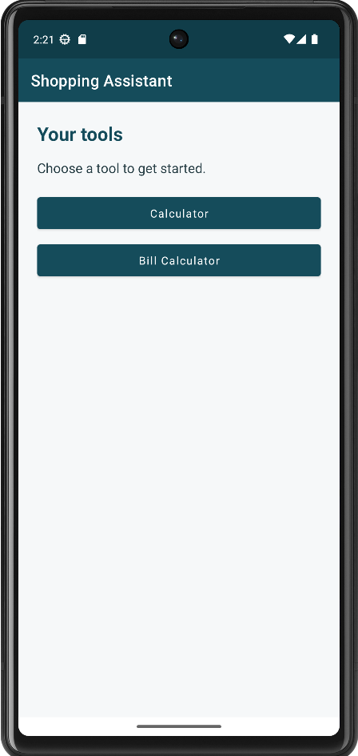  Figure 1 Phone Home | 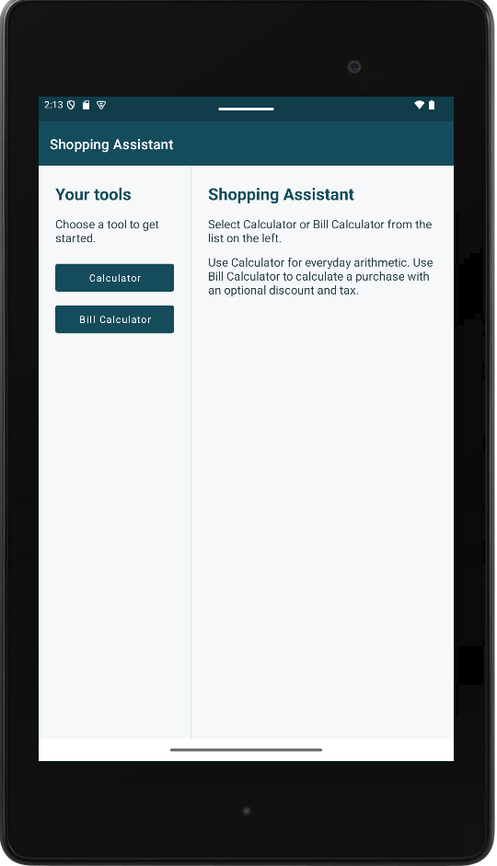  Figure 2 Wide Home with a persistent tool list

Application Screenshots
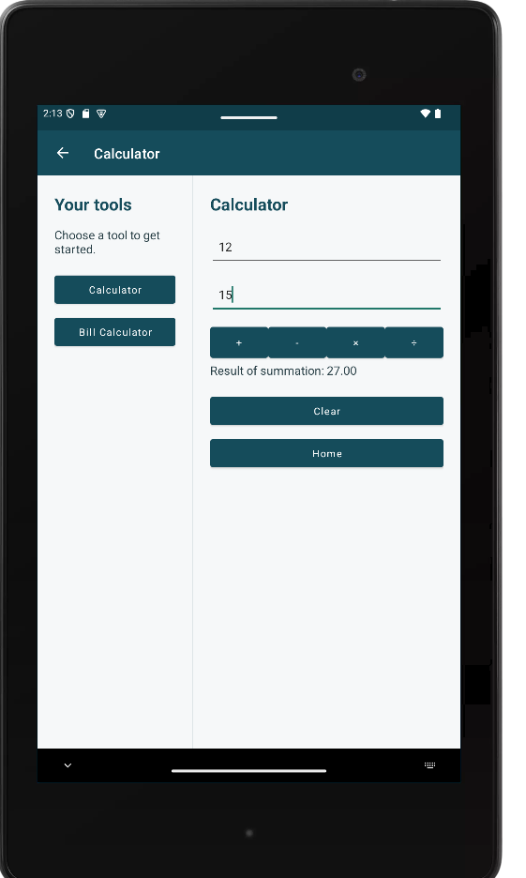  Figure 3 Summation on a wide screen | 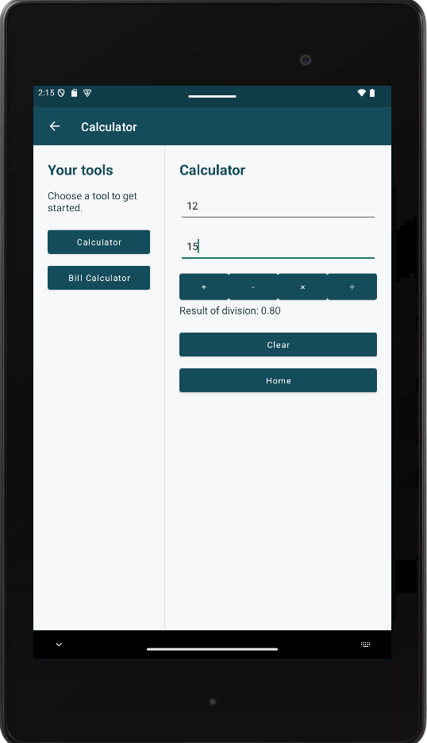  Figure 4 Division on a wide screen

Application Screenshots
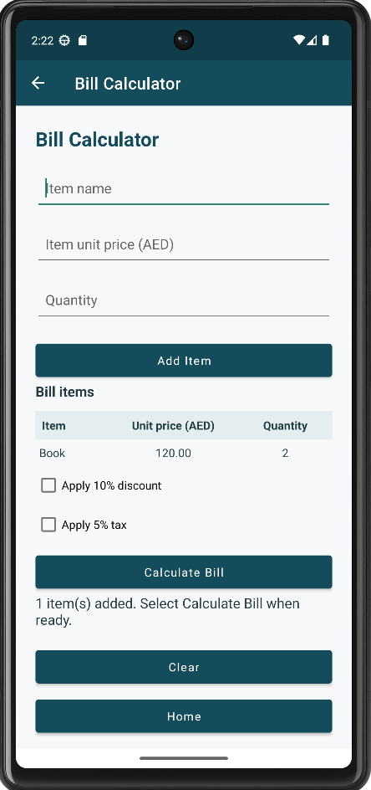  Figure 5 Phone Bill Calculator after Add Item | 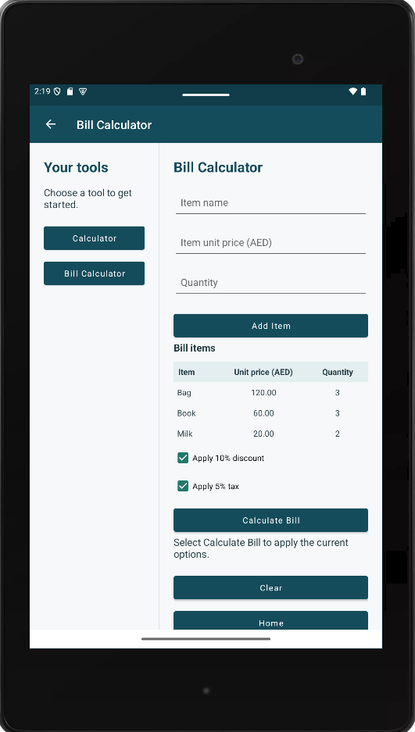  Figure 6 Wide Bill Calculator with three items
Use Add Item for each entry before Calculate Bill. The added item rows remain available when returning from Bill Summary.

Application Screenshots
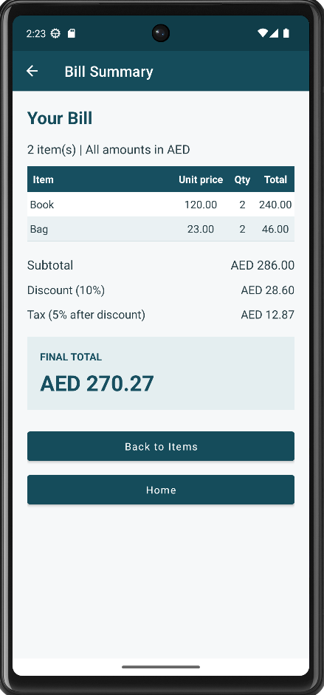  Figure 7 Phone Bill Summary with discount and tax | 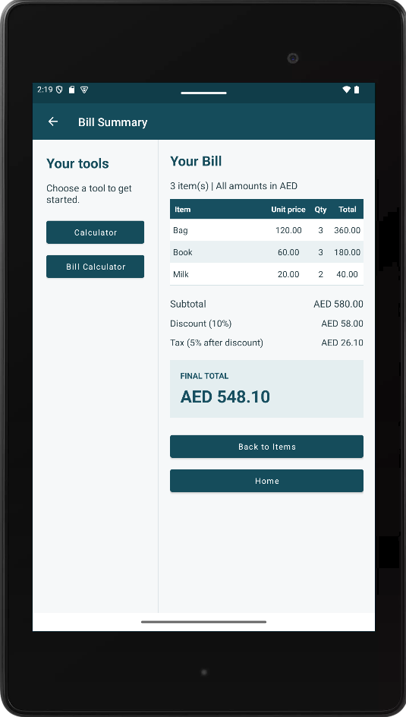  Figure 8 Wide Bill Summary with discount and tax
The phone bill contains Book at AED 120 × 2 and Bag at AED 23 × 2, giving a final total of AED 270.27 with both options. The wide-screen bill contains Bag at AED 120 × 3, Book at AED 60 × 3, and Milk at AED 20 × 2, giving AED 548.10 with both options. These are separate sample bills.

Short Explanation for CLO1
In 100 to 150 words, explain the roles of the Activity, NavHostFragment, NavController, and navigation graph. Explain how the phone and layout-w600dp layouts differ, and how the bill details are passed to Bill Summary while allowing a return to the item list.
MainActivity is the only Activity. It holds the Toolbar and a NavHostFragment, the container that shows one fragment at a time. The NavController, taken from that NavHostFragment, performs every move between screens. The navigation graph (nav_graph.xml) lists the four destinations (Home, Calculator, Bill Calculator, Bill Summary) and the actions between them. The phone layout contains only the Toolbar and the NavHostFragment, so one screen shows at a time. The layout-w600dp version also places ToolsFragment on the left, so the tool list stays visible while the NavHostFragment fills the right pane. Calculate Bill navigates to Bill Summary with the item names, prices, quantities and the two options packed in a Bundle. Bill Calculator stays on the back stack, so Back to Items, Up and system Back return to the same items and options.

Source Files
Use the following headings for your implementation. If your files have different names, identify the equivalent file. Add headings for any additional files. You may mark an unchanged supplied file as Unchanged supplied file; it must still be present in the project ZIP. A separate calculation helper is optional if the same logic is implemented within a Fragment.

BillFragment.kt
File: app/src/main/java/edu/aau/shoppingassistant/BillFragment.kt
package edu.aau.shoppingassistant

import android.os.Bundle
import android.view.View
import android.widget.Button
import android.widget.CheckBox
import android.widget.EditText
import android.widget.TableLayout
import android.widget.TextView
import androidx.fragment.app.Fragment
import androidx.navigation.fragment.findNavController
import com.google.android.material.textfield.TextInputLayout

class BillFragment : Fragment(R.layout.fragment_bill) {

private val items = mutableListOf<BillItem>()

private lateinit var nameLayout: TextInputLayout
private lateinit var priceLayout: TextInputLayout
private lateinit var quantityLayout: TextInputLayout
private lateinit var nameInput: EditText
private lateinit var priceInput: EditText
private lateinit var quantityInput: EditText
private lateinit var itemsTable: TableLayout
private lateinit var discountBox: CheckBox
private lateinit var taxBox: CheckBox
private lateinit var messageText: TextView

override fun onCreate(savedInstanceState: Bundle?) {
super.onCreate(savedInstanceState)
// After a screen rotation the Fragment is created again, so take the saved items back
if (savedInstanceState != null) {
items.addAll(unpackItems(savedInstanceState))
}
}

override fun onSaveInstanceState(outState: Bundle) {
super.onSaveInstanceState(outState)
outState.putAll(packItems(items))
}

override fun onViewCreated(view: View, savedInstanceState: Bundle?) {
super.onViewCreated(view, savedInstanceState)

nameLayout = view.findViewById<TextInputLayout>(R.id.tilItemName)
priceLayout = view.findViewById<TextInputLayout>(R.id.tilItemPrice)
quantityLayout = view.findViewById<TextInputLayout>(R.id.tilItemQuantity)
nameInput = view.findViewById<EditText>(R.id.etItemName)
priceInput = view.findViewById<EditText>(R.id.etItemPrice)
quantityInput = view.findViewById<EditText>(R.id.etItemQuantity)
itemsTable = view.findViewById<TableLayout>(R.id.tableItems)
discountBox = view.findViewById<CheckBox>(R.id.cbDiscount)
taxBox = view.findViewById<CheckBox>(R.id.cbTax)
messageText = view.findViewById<TextView>(R.id.tvBillMessage)

// The screen is built again every time it is shown (also when coming back from Bill Summary),
// so draw the table again from the list
showItems()

view.findViewById<Button>(R.id.btnAddItem).setOnClickListener { onAddItemClicked() }
view.findViewById<Button>(R.id.btnCalculateBill).setOnClickListener { onCalculateClicked() }
view.findViewById<Button>(R.id.btnBillClear).setOnClickListener { onClearClicked() }
view.findViewById<Button>(R.id.btnBillHome).setOnClickListener {
findNavController().popBackStack(R.id.homeFragment, false)
}
}

// Draws one table row for every item. Row 0 is the header from the XML, so it is kept.
private fun showItems() {
if (itemsTable.childCount > 1) {
itemsTable.removeViews(1, itemsTable.childCount - 1)
}
for (item in items) {
addTableRow(
itemsTable,
listOf(item.name, formatAmount(item.unitPrice), item.quantity.toString())
)
}
}

private fun onAddItemClicked() {
clearErrors()

val name = nameInput.text.toString().trim()
val price = parsePrice(priceInput.text.toString())
val quantity = parseQuantity(quantityInput.text.toString())

if (name.isEmpty()) nameLayout.error = getString(R.string.error_item_name)
if (price == null) priceLayout.error = getString(R.string.error_item_price)
if (quantity == null) quantityLayout.error = getString(R.string.error_item_quantity)

if (name.isEmpty() || price == null || quantity == null) {
messageText.text = getString(R.string.bill_message_not_added)
return
}

items.add(BillItem(name, price, quantity))
showItems()

nameInput.setText("")
priceInput.setText("")
quantityInput.setText("")
nameInput.requestFocus()

messageText.text = getString(R.string.bill_message_added, items.size)
}

private fun onCalculateClicked() {
clearErrors()

val hasDraftItem = nameInput.text.toString().isNotBlank() ||
priceInput.text.toString().isNotBlank() ||
quantityInput.text.toString().isNotBlank()
if (hasDraftItem) {
messageText.text = getString(R.string.bill_message_draft)
return
}

if (items.isEmpty()) {
messageText.text = getString(R.string.bill_message_empty)
return
}

val details = packBill(items, discountBox.isChecked, taxBox.isChecked)
findNavController().navigate(R.id.action_bill_to_summary, details)
}

private fun onClearClicked() {
items.clear()
showItems()
nameInput.setText("")
priceInput.setText("")
quantityInput.setText("")
clearErrors()
discountBox.isChecked = false
taxBox.isChecked = false
messageText.text = getString(R.string.bill_message_ready)
}

private fun clearErrors() {
nameLayout.error = null
priceLayout.error = null
quantityLayout.error = null
}
}

BillSummaryFragment.kt
File: app/src/main/java/edu/aau/shoppingassistant/BillSummaryFragment.kt
package edu.aau.shoppingassistant

import android.os.Bundle
import android.view.View
import android.widget.Button
import android.widget.TableLayout
import android.widget.TextView
import androidx.fragment.app.Fragment
import androidx.navigation.fragment.findNavController

class BillSummaryFragment : Fragment(R.layout.fragment_bill_summary) {

override fun onViewCreated(view: View, savedInstanceState: Bundle?) {
super.onViewCreated(view, savedInstanceState)

val items = unpackItems(arguments)
val applyDiscount = arguments?.getBoolean(KEY_DISCOUNT, false) ?: false
val applyTax = arguments?.getBoolean(KEY_TAX, false) ?: false
val totals = calculateBill(items, applyDiscount, applyTax)

val table = view.findViewById<TableLayout>(R.id.tableSummaryItems)
for (item in items) {
addTableRow(
table,
listOf(
item.name,
formatAmount(item.unitPrice),
item.quantity.toString(),
formatAmount(item.lineTotal)
)
)
}

view.findViewById<TextView>(R.id.tvSummaryInfo).text =
getString(R.string.summary_info, items.size)
view.findViewById<TextView>(R.id.tvSubtotal).text =
getString(R.string.amount_aed, formatAmount(totals.subtotal))
view.findViewById<TextView>(R.id.tvDiscount).text =
getString(R.string.amount_aed, formatAmount(totals.discount))
view.findViewById<TextView>(R.id.tvTax).text =
getString(R.string.amount_aed, formatAmount(totals.tax))
view.findViewById<TextView>(R.id.tvFinalTotal).text =
getString(R.string.amount_aed, formatAmount(totals.finalTotal))

view.findViewById<Button>(R.id.btnSummaryBack).setOnClickListener {
findNavController().popBackStack()
}
view.findViewById<Button>(R.id.btnSummaryHome).setOnClickListener {
findNavController().popBackStack(R.id.homeFragment, false)
}
}
}

Calculations.kt
File: app/src/main/java/edu/aau/shoppingassistant/Calculations.kt
package edu.aau.shoppingassistant

import java.util.Locale
import kotlin.math.abs

// Pure Kotlin logic (no Android classes), so it is easy to read and to test.

const val MAX_CALCULATOR_NUMBER = 1_000_000_000.0
const val MAX_CALCULATOR_RESULT = 1_000_000_000_000_000_000.0
const val MAX_UNIT_PRICE = 1_000_000.0
const val MAX_QUANTITY = 100_000
const val DISCOUNT_RATE = 0.10
const val TAX_RATE = 0.05

enum class Operation(val displayName: String) {
ADD("summation"),
SUBTRACT("subtraction"),
MULTIPLY("multiplication"),
DIVIDE("division")
}

data class BillItem(val name: String, val unitPrice: Double, val quantity: Int) {
val lineTotal: Double
get() = unitPrice * quantity
}

data class BillTotals(
val subtotal: Double,
val discount: Double,
val tax: Double,
val finalTotal: Double
)

fun parseNumber(text: String): Double? {
val value = text.trim().toDoubleOrNull() ?: return null
if (!value.isFinite() || abs(value) > MAX_CALCULATOR_NUMBER) return null
return value
}

fun calculateResult(a: Double, b: Double, operation: Operation): Double {
return when (operation) {
Operation.ADD -> a + b
Operation.SUBTRACT -> a - b
Operation.MULTIPLY -> a * b
Operation.DIVIDE -> a / b
}
}

// True when the result cannot be shown clearly (infinite, or an unreadably huge number)
fun isResultTooLarge(result: Double): Boolean {
return !result.isFinite() || abs(result) > MAX_CALCULATOR_RESULT
}

fun parsePrice(text: String): Double? {
val value = text.trim().toDoubleOrNull() ?: return null
if (!value.isFinite() || value <= 0.0 || value > MAX_UNIT_PRICE) return null
return value
}

fun parseQuantity(text: String): Int? {
val value = text.trim().toIntOrNull() ?: return null
if (value < 1 || value > MAX_QUANTITY) return null
return value
}

fun calculateBill(items: List<BillItem>, applyDiscount: Boolean, applyTax: Boolean): BillTotals {
var subtotal = 0.0
for (item in items) {
subtotal += item.lineTotal
}
val discount = if (applyDiscount) subtotal * DISCOUNT_RATE else 0.0
val amountAfterDiscount = subtotal - discount
val tax = if (applyTax) amountAfterDiscount * TAX_RATE else 0.0
return BillTotals(subtotal, discount, tax, amountAfterDiscount + tax)
}

// Two decimals with a dot, whatever the phone language is. Never shows -0.00.
fun formatAmount(value: Double): String {
val text = String.format(Locale.US, "%.2f", value)
return if (text == "-0.00") "0.00" else text
}

CalculatorFragment.kt
File: app/src/main/java/edu/aau/shoppingassistant/CalculatorFragment.kt
package edu.aau.shoppingassistant

import android.os.Bundle
import android.view.View
import android.widget.Button
import android.widget.EditText
import android.widget.TextView
import androidx.fragment.app.Fragment
import androidx.navigation.fragment.findNavController
import com.google.android.material.textfield.TextInputLayout

class CalculatorFragment : Fragment(R.layout.fragment_calculator) {

private lateinit var number1Layout: TextInputLayout
private lateinit var number2Layout: TextInputLayout
private lateinit var number1Input: EditText
private lateinit var number2Input: EditText
private lateinit var resultText: TextView

override fun onViewCreated(view: View, savedInstanceState: Bundle?) {
super.onViewCreated(view, savedInstanceState)

number1Layout = view.findViewById<TextInputLayout>(R.id.tilNumber1)
number2Layout = view.findViewById<TextInputLayout>(R.id.tilNumber2)
number1Input = view.findViewById<EditText>(R.id.etNumber1)
number2Input = view.findViewById<EditText>(R.id.etNumber2)
resultText = view.findViewById<TextView>(R.id.tvResult)

view.findViewById<Button>(R.id.btnAdd).setOnClickListener { onOperationClicked(Operation.ADD) }
view.findViewById<Button>(R.id.btnSubtract).setOnClickListener { onOperationClicked(Operation.SUBTRACT) }
view.findViewById<Button>(R.id.btnMultiply).setOnClickListener { onOperationClicked(Operation.MULTIPLY) }
view.findViewById<Button>(R.id.btnDivide).setOnClickListener { onOperationClicked(Operation.DIVIDE) }

view.findViewById<Button>(R.id.btnCalcClear).setOnClickListener { onClearClicked() }
view.findViewById<Button>(R.id.btnCalcHome).setOnClickListener {
findNavController().popBackStack(R.id.homeFragment, false)
}
}

private fun onOperationClicked(operation: Operation) {
number1Layout.error = null
number2Layout.error = null

val a = parseNumber(number1Input.text.toString())
val b = parseNumber(number2Input.text.toString())

if (a == null) number1Layout.error = getString(R.string.error_number)
if (b == null) number2Layout.error = getString(R.string.error_number)
if (a == null || b == null) {
resultText.text = getString(R.string.calc_no_result)
return
}

if (operation == Operation.DIVIDE && b == 0.0) {
number2Layout.error = getString(R.string.error_divide_by_zero)
resultText.text = getString(R.string.calc_no_result)
return
}

val result = calculateResult(a, b, operation)
if (isResultTooLarge(result)) {
resultText.text = getString(R.string.error_too_large)
return
}

resultText.text = getString(R.string.calc_result, operation.displayName, formatAmount(result))
}

private fun onClearClicked() {
number1Input.setText("")
number2Input.setText("")
number1Layout.error = null
number2Layout.error = null
resultText.text = getString(R.string.calc_default_result)
}
}

HomeFragment.kt
File: app/src/main/java/edu/aau/shoppingassistant/HomeFragment.kt
package edu.aau.shoppingassistant

import android.os.Bundle
import android.view.View
import androidx.fragment.app.Fragment

class HomeFragment : Fragment(R.layout.fragment_home) {

override fun onViewCreated(view: View, savedInstanceState: Bundle?) {
super.onViewCreated(view, savedInstanceState)

connectToolButtons(this, view)
}
}

MainActivity.kt
File: app/src/main/java/edu/aau/shoppingassistant/MainActivity.kt
package edu.aau.shoppingassistant

import android.os.Bundle
import androidx.appcompat.app.AppCompatActivity
import androidx.appcompat.widget.Toolbar
import androidx.navigation.NavController
import androidx.navigation.fragment.NavHostFragment
import androidx.navigation.ui.AppBarConfiguration
import androidx.navigation.ui.navigateUp
import androidx.navigation.ui.setupActionBarWithNavController

class MainActivity : AppCompatActivity() {

private lateinit var navController: NavController
private lateinit var appBarConfiguration: AppBarConfiguration

override fun onCreate(savedInstanceState: Bundle?) {
super.onCreate(savedInstanceState)
setContentView(R.layout.activity_main)

setSupportActionBar(findViewById<Toolbar>(R.id.toolbar))

val navHostFragment = supportFragmentManager
.findFragmentById(R.id.navHostFragment) as NavHostFragment
navController = navHostFragment.navController

// Home is the top level screen, so it shows no Up arrow. All other screens show the Up arrow.
appBarConfiguration = AppBarConfiguration(setOf(R.id.homeFragment))
setupActionBarWithNavController(navController, appBarConfiguration)
}

override fun onSupportNavigateUp(): Boolean {
return navController.navigateUp(appBarConfiguration) || super.onSupportNavigateUp()
}
}

ToolsFragment.kt
File: app/src/main/java/edu/aau/shoppingassistant/ToolsFragment.kt
package edu.aau.shoppingassistant

import android.os.Bundle
import android.view.View
import android.widget.Button
import androidx.fragment.app.Fragment
import androidx.navigation.fragment.NavHostFragment

class ToolsFragment : Fragment(R.layout.fragment_tools) {

override fun onViewCreated(view: View, savedInstanceState: Bundle?) {
super.onViewCreated(view, savedInstanceState)
connectToolButtons(this, view)
}
}

fun connectToolButtons(fragment: Fragment, view: View) {
view.findViewById<Button>(R.id.btnCalculator)?.setOnClickListener {
openTool(fragment, R.id.calculatorFragment)
}
view.findViewById<Button>(R.id.btnBill)?.setOnClickListener {
openTool(fragment, R.id.billFragment)
}
}

// Shows a tool in the NavHostFragment. The NavHostFragment is looked up through the Activity,
// because ToolsFragment is not inside it (on a wide screen it sits next to it).
fun openTool(fragment: Fragment, destinationId: Int) {
val navHostFragment = fragment.requireActivity().supportFragmentManager
.findFragmentById(R.id.navHostFragment) as NavHostFragment
val navController = navHostFragment.navController
val current = navController.currentDestination?.id

if (current == destinationId) return

// From Bill Summary the Bill Calculator button goes back to the existing bill
if (current == R.id.billSummaryFragment && destinationId == R.id.billFragment) {
navController.popBackStack()
return
}

if (destinationId == R.id.calculatorFragment) {
navController.navigate(R.id.action_global_calculator)
} else {
navController.navigate(R.id.action_global_bill)
}
}

AndroidManifest.xml
File: app/src/main/AndroidManifest.xml
<?xml version="1.0" encoding="utf-8"?>
<manifest xmlns:android="http://schemas.android.com/apk/res/android">

<application
android:allowBackup="false"
android:label="@string/app_name"
android:supportsRtl="true"
android:theme="@style/AppTheme">

<activity
android:name=".MainActivity"
android:exported="true"
android:windowSoftInputMode="adjustResize">
<intent-filter>
<action android:name="android.intent.action.MAIN" />
<category android:name="android.intent.category.LAUNCHER" />
</intent-filter>
</activity>

</application>

</manifest>

activity_main.xml
File: app/src/main/res/layout/activity_main.xml
<?xml version="1.0" encoding="utf-8"?>
<LinearLayout xmlns:android="http://schemas.android.com/apk/res/android"
xmlns:app="http://schemas.android.com/apk/res-auto"
android:layout_width="match_parent"
android:layout_height="match_parent"
android:orientation="vertical">

<androidx.appcompat.widget.Toolbar
android:id="@+id/toolbar"
android:layout_width="match_parent"
android:layout_height="?attr/actionBarSize"
android:background="?attr/colorPrimary"
android:elevation="4dp"
android:theme="@style/ThemeOverlay.AppCompat.Dark.ActionBar"
app:popupTheme="@style/ThemeOverlay.AppCompat.Light" />

<androidx.fragment.app.FragmentContainerView
android:id="@+id/navHostFragment"
android:name="androidx.navigation.fragment.NavHostFragment"
android:layout_width="match_parent"
android:layout_height="0dp"
android:layout_weight="1"
app:defaultNavHost="true"
app:navGraph="@navigation/nav_graph" />

</LinearLayout>

fragment_bill.xml
File: app/src/main/res/layout/fragment_bill.xml
<?xml version="1.0" encoding="utf-8"?>
<ScrollView xmlns:android="http://schemas.android.com/apk/res/android"
android:layout_width="match_parent"
android:layout_height="match_parent">

<LinearLayout
android:layout_width="match_parent"
android:layout_height="wrap_content"
android:orientation="vertical"
android:padding="20dp">

<TextView
style="@style/ShopHeading"
android:layout_width="wrap_content"
android:layout_height="wrap_content"
android:text="@string/bill_heading" />

<com.google.android.material.textfield.TextInputLayout
android:id="@+id/tilItemName"
style="@style/Widget.MaterialComponents.TextInputLayout.OutlinedBox"
android:layout_width="match_parent"
android:layout_height="wrap_content"
android:layout_marginTop="16dp"
android:hint="@string/hint_item_name">

<com.google.android.material.textfield.TextInputEditText
android:id="@+id/etItemName"
android:layout_width="match_parent"
android:layout_height="wrap_content"
android:imeOptions="actionNext"
android:inputType="textCapWords" />
</com.google.android.material.textfield.TextInputLayout>

<com.google.android.material.textfield.TextInputLayout
android:id="@+id/tilItemPrice"
style="@style/Widget.MaterialComponents.TextInputLayout.OutlinedBox"
android:layout_width="match_parent"
android:layout_height="wrap_content"
android:layout_marginTop="12dp"
android:hint="@string/hint_item_price">

<com.google.android.material.textfield.TextInputEditText
android:id="@+id/etItemPrice"
android:layout_width="match_parent"
android:layout_height="wrap_content"
android:imeOptions="actionNext"
android:inputType="numberDecimal" />
</com.google.android.material.textfield.TextInputLayout>

<com.google.android.material.textfield.TextInputLayout
android:id="@+id/tilItemQuantity"
style="@style/Widget.MaterialComponents.TextInputLayout.OutlinedBox"
android:layout_width="match_parent"
android:layout_height="wrap_content"
android:layout_marginTop="12dp"
android:hint="@string/hint_item_quantity">

<com.google.android.material.textfield.TextInputEditText
android:id="@+id/etItemQuantity"
android:layout_width="match_parent"
android:layout_height="wrap_content"
android:imeOptions="actionDone"
android:inputType="number" />
</com.google.android.material.textfield.TextInputLayout>

<com.google.android.material.button.MaterialButton
android:id="@+id/btnAddItem"
android:layout_width="match_parent"
android:layout_height="wrap_content"
android:layout_marginTop="16dp"
android:text="@string/button_add_item" />

<TextView
style="@style/ShopLabel"
android:layout_width="wrap_content"
android:layout_height="wrap_content"
android:layout_marginTop="20dp"
android:text="@string/label_bill_items" />

<!-- The first row is the header. BillFragment.kt adds one row for every item. -->
<TableLayout
android:id="@+id/tableItems"
android:layout_width="match_parent"
android:layout_height="wrap_content"
android:layout_marginTop="8dp"
android:stretchColumns="*">

<TableRow android:background="#E3EDF0">

<TextView
style="@style/TableHeader"
android:layout_width="wrap_content"
android:layout_height="wrap_content"
android:text="@string/col_item" />

<TextView
style="@style/TableHeader"
android:layout_width="wrap_content"
android:layout_height="wrap_content"
android:gravity="end"
android:text="@string/col_unit_price" />

<TextView
style="@style/TableHeader"
android:layout_width="wrap_content"
android:layout_height="wrap_content"
android:gravity="end"
android:text="@string/col_quantity" />
</TableRow>
</TableLayout>

<CheckBox
android:id="@+id/cbDiscount"
style="@style/ShopBody"
android:layout_width="wrap_content"
android:layout_height="wrap_content"
android:layout_marginTop="12dp"
android:text="@string/option_discount" />

<CheckBox
android:id="@+id/cbTax"
style="@style/ShopBody"
android:layout_width="wrap_content"
android:layout_height="wrap_content"
android:text="@string/option_tax" />

<com.google.android.material.button.MaterialButton
android:id="@+id/btnCalculateBill"
android:layout_width="match_parent"
android:layout_height="wrap_content"
android:layout_marginTop="12dp"
android:text="@string/button_calculate_bill" />

<TextView
android:id="@+id/tvBillMessage"
style="@style/ShopBody"
android:layout_width="match_parent"
android:layout_height="wrap_content"
android:layout_marginTop="12dp"
android:text="@string/bill_message_ready" />

<com.google.android.material.button.MaterialButton
android:id="@+id/btnBillClear"
style="@style/Widget.MaterialComponents.Button.OutlinedButton"
android:layout_width="match_parent"
android:layout_height="wrap_content"
android:layout_marginTop="16dp"
android:text="@string/button_clear" />

<com.google.android.material.button.MaterialButton
android:id="@+id/btnBillHome"
style="@style/Widget.MaterialComponents.Button.OutlinedButton"
android:layout_width="match_parent"
android:layout_height="wrap_content"
android:layout_marginTop="8dp"
android:text="@string/button_home" />

</LinearLayout>
</ScrollView>

fragment_bill_summary.xml
File: app/src/main/res/layout/fragment_bill_summary.xml
<?xml version="1.0" encoding="utf-8"?>
<ScrollView xmlns:android="http://schemas.android.com/apk/res/android"
android:layout_width="match_parent"
android:layout_height="match_parent">

<LinearLayout
android:layout_width="match_parent"
android:layout_height="wrap_content"
android:orientation="vertical"
android:padding="20dp">

<TextView
style="@style/ShopHeading"
android:layout_width="wrap_content"
android:layout_height="wrap_content"
android:text="@string/summary_heading" />

<TextView
android:id="@+id/tvSummaryInfo"
style="@style/ShopBody"
android:layout_width="wrap_content"
android:layout_height="wrap_content"
android:layout_marginTop="8dp" />

<!-- The first row is the header. BillSummaryFragment.kt adds one row for every item. -->
<TableLayout
android:id="@+id/tableSummaryItems"
android:layout_width="match_parent"
android:layout_height="wrap_content"
android:layout_marginTop="12dp"
android:stretchColumns="*">

<TableRow android:background="#E3EDF0">

<TextView
style="@style/TableHeader"
android:layout_width="wrap_content"
android:layout_height="wrap_content"
android:text="@string/col_item" />

<TextView
style="@style/TableHeader"
android:layout_width="wrap_content"
android:layout_height="wrap_content"
android:gravity="end"
android:text="@string/col_summary_unit_price" />

<TextView
style="@style/TableHeader"
android:layout_width="wrap_content"
android:layout_height="wrap_content"
android:gravity="end"
android:text="@string/col_summary_quantity" />

<TextView
style="@style/TableHeader"
android:layout_width="wrap_content"
android:layout_height="wrap_content"
android:gravity="end"
android:text="@string/col_summary_total" />
</TableRow>
</TableLayout>

<TableLayout
android:layout_width="match_parent"
android:layout_height="wrap_content"
android:layout_marginTop="16dp"
android:stretchColumns="0">

<TableRow>

<TextView
style="@style/ShopBody"
android:layout_width="wrap_content"
android:layout_height="wrap_content"
android:padding="4dp"
android:text="@string/label_subtotal" />

<TextView
android:id="@+id/tvSubtotal"
style="@style/ShopBody"
android:layout_width="wrap_content"
android:layout_height="wrap_content"
android:gravity="end"
android:padding="4dp" />
</TableRow>

<TableRow>

<TextView
style="@style/ShopBody"
android:layout_width="wrap_content"
android:layout_height="wrap_content"
android:padding="4dp"
android:text="@string/label_discount" />

<TextView
android:id="@+id/tvDiscount"
style="@style/ShopBody"
android:layout_width="wrap_content"
android:layout_height="wrap_content"
android:gravity="end"
android:padding="4dp" />
</TableRow>

<TableRow>

<TextView
style="@style/ShopBody"
android:layout_width="wrap_content"
android:layout_height="wrap_content"
android:padding="4dp"
android:text="@string/label_tax" />

<TextView
android:id="@+id/tvTax"
style="@style/ShopBody"
android:layout_width="wrap_content"
android:layout_height="wrap_content"
android:gravity="end"
android:padding="4dp" />
</TableRow>
</TableLayout>

<LinearLayout
android:layout_width="match_parent"
android:layout_height="wrap_content"
android:layout_marginTop="16dp"
android:background="#E3EDF0"
android:orientation="vertical"
android:padding="16dp">

<TextView
style="@style/ShopLabel"
android:layout_width="wrap_content"
android:layout_height="wrap_content"
android:text="@string/label_final_total" />

<TextView
android:id="@+id/tvFinalTotal"
style="@style/ShopTotal"
android:layout_width="wrap_content"
android:layout_height="wrap_content"
android:layout_marginTop="4dp" />
</LinearLayout>

<com.google.android.material.button.MaterialButton
android:id="@+id/btnSummaryBack"
android:layout_width="match_parent"
android:layout_height="wrap_content"
android:layout_marginTop="20dp"
android:text="@string/button_back_to_items" />

<com.google.android.material.button.MaterialButton
android:id="@+id/btnSummaryHome"
style="@style/Widget.MaterialComponents.Button.OutlinedButton"
android:layout_width="match_parent"
android:layout_height="wrap_content"
android:layout_marginTop="8dp"
android:text="@string/button_home" />

</LinearLayout>
</ScrollView>

fragment_calculator.xml
File: app/src/main/res/layout/fragment_calculator.xml
<?xml version="1.0" encoding="utf-8"?>
<ScrollView xmlns:android="http://schemas.android.com/apk/res/android"
android:layout_width="match_parent"
android:layout_height="match_parent">

<LinearLayout
android:layout_width="match_parent"
android:layout_height="wrap_content"
android:orientation="vertical"
android:padding="20dp">

<TextView
style="@style/ShopHeading"
android:layout_width="wrap_content"
android:layout_height="wrap_content"
android:text="@string/calc_heading" />

<com.google.android.material.textfield.TextInputLayout
android:id="@+id/tilNumber1"
style="@style/Widget.MaterialComponents.TextInputLayout.OutlinedBox"
android:layout_width="match_parent"
android:layout_height="wrap_content"
android:layout_marginTop="16dp"
android:hint="@string/hint_number_1">

<com.google.android.material.textfield.TextInputEditText
android:id="@+id/etNumber1"
android:layout_width="match_parent"
android:layout_height="wrap_content"
android:imeOptions="actionNext"
android:inputType="numberDecimal|numberSigned" />
</com.google.android.material.textfield.TextInputLayout>

<com.google.android.material.textfield.TextInputLayout
android:id="@+id/tilNumber2"
style="@style/Widget.MaterialComponents.TextInputLayout.OutlinedBox"
android:layout_width="match_parent"
android:layout_height="wrap_content"
android:layout_marginTop="12dp"
android:hint="@string/hint_number_2">

<com.google.android.material.textfield.TextInputEditText
android:id="@+id/etNumber2"
android:layout_width="match_parent"
android:layout_height="wrap_content"
android:imeOptions="actionDone"
android:inputType="numberDecimal|numberSigned" />
</com.google.android.material.textfield.TextInputLayout>

<LinearLayout
android:layout_width="match_parent"
android:layout_height="wrap_content"
android:layout_marginTop="16dp"
android:orientation="horizontal">

<com.google.android.material.button.MaterialButton
android:id="@+id/btnAdd"
android:layout_width="0dp"
android:layout_height="wrap_content"
android:layout_marginEnd="4dp"
android:layout_weight="1"
android:contentDescription="@string/op_add_description"
android:text="@string/op_add"
android:textSize="20sp" />

<com.google.android.material.button.MaterialButton
android:id="@+id/btnSubtract"
android:layout_width="0dp"
android:layout_height="wrap_content"
android:layout_marginStart="4dp"
android:layout_marginEnd="4dp"
android:layout_weight="1"
android:contentDescription="@string/op_subtract_description"
android:text="@string/op_subtract"
android:textSize="20sp" />

<com.google.android.material.button.MaterialButton
android:id="@+id/btnMultiply"
android:layout_width="0dp"
android:layout_height="wrap_content"
android:layout_marginStart="4dp"
android:layout_marginEnd="4dp"
android:layout_weight="1"
android:contentDescription="@string/op_multiply_description"
android:text="@string/op_multiply"
android:textSize="20sp" />

<com.google.android.material.button.MaterialButton
android:id="@+id/btnDivide"
android:layout_width="0dp"
android:layout_height="wrap_content"
android:layout_marginStart="4dp"
android:layout_weight="1"
android:contentDescription="@string/op_divide_description"
android:text="@string/op_divide"
android:textSize="20sp" />
</LinearLayout>

<TextView
android:id="@+id/tvResult"
style="@style/ShopBody"
android:layout_width="match_parent"
android:layout_height="wrap_content"
android:layout_marginTop="16dp"
android:text="@string/calc_default_result" />

<com.google.android.material.button.MaterialButton
android:id="@+id/btnCalcClear"
style="@style/Widget.MaterialComponents.Button.OutlinedButton"
android:layout_width="match_parent"
android:layout_height="wrap_content"
android:layout_marginTop="16dp"
android:text="@string/button_clear" />

<com.google.android.material.button.MaterialButton
android:id="@+id/btnCalcHome"
style="@style/Widget.MaterialComponents.Button.OutlinedButton"
android:layout_width="match_parent"
android:layout_height="wrap_content"
android:layout_marginTop="8dp"
android:text="@string/button_home" />

</LinearLayout>
</ScrollView>

fragment_tools.xml
File: app/src/main/res/layout/fragment_tools.xml
<?xml version="1.0" encoding="utf-8"?>
<LinearLayout xmlns:android="http://schemas.android.com/apk/res/android"
android:layout_width="match_parent"
android:layout_height="match_parent"
android:orientation="vertical"
android:padding="20dp">

<TextView
style="@style/ShopHeading"
android:layout_width="wrap_content"
android:layout_height="wrap_content"
android:text="@string/tools_heading" />

<TextView
style="@style/ShopBody"
android:layout_width="wrap_content"
android:layout_height="wrap_content"
android:layout_marginTop="12dp"
android:text="@string/tools_hint" />

<com.google.android.material.button.MaterialButton
android:id="@+id/btnCalculator"
android:layout_width="match_parent"
android:layout_height="wrap_content"
android:layout_marginTop="20dp"
android:text="@string/tool_calculator" />

<com.google.android.material.button.MaterialButton
android:id="@+id/btnBill"
android:layout_width="match_parent"
android:layout_height="wrap_content"
android:layout_marginTop="12dp"
android:text="@string/tool_bill" />

</LinearLayout>

activity_main.xml — wide layout
File: app/src/main/res/layout-w600dp/activity_main.xml
<?xml version="1.0" encoding="utf-8"?>
<LinearLayout xmlns:android="http://schemas.android.com/apk/res/android"
xmlns:app="http://schemas.android.com/apk/res-auto"
android:layout_width="match_parent"
android:layout_height="match_parent"
android:orientation="vertical">

<androidx.appcompat.widget.Toolbar
android:id="@+id/toolbar"
android:layout_width="match_parent"
android:layout_height="?attr/actionBarSize"
android:background="?attr/colorPrimary"
android:elevation="4dp"
android:theme="@style/ThemeOverlay.AppCompat.Dark.ActionBar"
app:popupTheme="@style/ThemeOverlay.AppCompat.Light" />

<LinearLayout
android:layout_width="match_parent"
android:layout_height="0dp"
android:layout_weight="1"
android:orientation="horizontal">

<androidx.fragment.app.FragmentContainerView
android:id="@+id/toolsContainer"
android:name="edu.aau.shoppingassistant.ToolsFragment"
android:layout_width="220dp"
android:layout_height="match_parent" />

<View
android:layout_width="1dp"
android:layout_height="match_parent"
android:background="#D5DEE2" />

<androidx.fragment.app.FragmentContainerView
android:id="@+id/navHostFragment"
android:name="androidx.navigation.fragment.NavHostFragment"
android:layout_width="0dp"
android:layout_height="match_parent"
android:layout_weight="1"
app:defaultNavHost="true"
app:navGraph="@navigation/nav_graph" />
</LinearLayout>

</LinearLayout>

nav_graph.xml
File: app/src/main/res/navigation/nav_graph.xml
<?xml version="1.0" encoding="utf-8"?>
<!-- The android:label of each screen becomes the Toolbar title. -->
<navigation xmlns:android="http://schemas.android.com/apk/res/android"
xmlns:app="http://schemas.android.com/apk/res-auto"
android:id="@+id/nav_graph"
app:startDestination="@id/homeFragment">

<!-- popUpTo Home removes every screen above Home first, so repeated tool selections never stack duplicate screens -->
<action
android:id="@+id/action_global_calculator"
app:destination="@id/calculatorFragment"
app:popUpTo="@id/homeFragment" />

<action
android:id="@+id/action_global_bill"
app:destination="@id/billFragment"
app:popUpTo="@id/homeFragment" />

<fragment
android:id="@+id/homeFragment"
android:name="edu.aau.shoppingassistant.HomeFragment"
android:label="@string/title_home" />

<fragment
android:id="@+id/calculatorFragment"
android:name="edu.aau.shoppingassistant.CalculatorFragment"
android:label="@string/title_calculator" />

<fragment
android:id="@+id/billFragment"
android:name="edu.aau.shoppingassistant.BillFragment"
android:label="@string/title_bill">

<action
android:id="@+id/action_bill_to_summary"
app:destination="@id/billSummaryFragment" />
</fragment>

<fragment
android:id="@+id/billSummaryFragment"
android:name="edu.aau.shoppingassistant.BillSummaryFragment"
android:label="@string/title_summary" />

</navigation>

strings.xml
File: app/src/main/res/values/strings.xml
<?xml version="1.0" encoding="utf-8"?>
<resources>
<string name="app_name">Shopping Assistant</string>

<!-- Screen titles -->
<string name="title_home">Shopping Assistant</string>
<string name="title_calculator">Calculator</string>
<string name="title_bill">Bill Calculator</string>
<string name="title_summary">Bill Summary</string>

<!-- Buttons used on more than one screen -->
<string name="button_clear">Clear</string>
<string name="button_home">Home</string>

<!-- Tool list and Home -->
<string name="tools_heading">Your tools</string>
<string name="tools_hint">Choose a tool to get started.</string>
<string name="tool_calculator">Calculator</string>
<string name="tool_bill">Bill Calculator</string>
<string name="welcome_heading">Shopping Assistant</string>
<string name="welcome_text_1">Select Calculator or Bill Calculator from the list on the left.</string>
<string name="welcome_text_2">Use Calculator for everyday arithmetic. Use Bill Calculator to calculate a purchase with an optional discount and tax.</string>

<!-- Calculator -->
<string name="calc_heading">Calculator</string>
<string name="hint_number_1">First number</string>
<string name="hint_number_2">Second number</string>
<string name="op_add">+</string>
<string name="op_subtract">−</string>
<string name="op_multiply">×</string>
<string name="op_divide">÷</string>
<string name="op_add_description">Add</string>
<string name="op_subtract_description">Subtract</string>
<string name="op_multiply_description">Multiply</string>
<string name="op_divide_description">Divide</string>
<string name="calc_default_result">Choose an operation to see the result.</string>
<string name="calc_result">Result of %1$s: %2$s</string>
<string name="calc_no_result">No result. Fix the number fields.</string>
<string name="error_number">Enter a valid number, for example 12 or -3.5</string>
<string name="error_divide_by_zero">Cannot divide by zero</string>
<string name="error_too_large">The result is too large to show.</string>

<!-- Bill Calculator -->
<string name="bill_heading">Bill Calculator</string>
<string name="hint_item_name">Item name</string>
<string name="hint_item_price">Item unit price (AED)</string>
<string name="hint_item_quantity">Quantity</string>
<string name="button_add_item">Add Item</string>
<string name="label_bill_items">Bill items</string>
<string name="col_item">Item</string>
<string name="col_unit_price">Unit price (AED)</string>
<string name="col_quantity">Quantity</string>
<string name="option_discount" formatted="false">Apply 10% discount</string>
<string name="option_tax" formatted="false">Apply 5% tax</string>
<string name="button_calculate_bill">Calculate Bill</string>
<string name="bill_message_ready">Add items, then select Calculate Bill.</string>
<string name="bill_message_added">Item added. Items in the bill: %1$d</string>
<string name="bill_message_not_added">The item was not added. Fix the fields marked in red.</string>
<string name="bill_message_draft">An item is typed but not added. Select Add Item, or clear those fields, before calculating.</string>
<string name="bill_message_empty">The bill has no items. Add at least one item first.</string>
<string name="error_item_name">Enter the item name</string>
<string name="error_item_price">Price must be a number greater than 0</string>
<string name="error_item_quantity">Quantity must be a whole number greater than 0</string>

<!-- Bill Summary -->
<string name="summary_heading">Your Bill</string>
<string name="summary_info">%1$d item(s) | All amounts in AED</string>
<string name="col_summary_unit_price">Unit price</string>
<string name="col_summary_quantity">Qty</string>
<string name="col_summary_total">Total</string>
<string name="label_subtotal">Subtotal</string>
<string name="label_discount" formatted="false">Discount (10%)</string>
<string name="label_tax" formatted="false">Tax (5% after discount)</string>
<string name="label_final_total">FINAL TOTAL</string>
<string name="amount_aed">AED %1$s</string>
<string name="button_back_to_items">Back to Items</string>
</resources>

styles.xml
File: app/src/main/res/values/styles.xml
<?xml version="1.0" encoding="utf-8"?>
<resources>

<!-- App theme. NoActionBar lets us use our own Toolbar. -->
<style name="AppTheme" parent="Theme.MaterialComponents.Light.NoActionBar">
<item name="colorPrimary">#154C5B</item>
<item name="colorPrimaryVariant">#103D49</item>
<item name="colorSecondary">#21786A</item>
<item name="android:fontFamily">sans</item>
<item name="android:statusBarColor">#103D49</item>
<item name="android:windowBackground">#F6F8FA</item>
</style>

<style name="ShopHeading">
<item name="android:textSize">24sp</item>
<item name="android:textStyle">bold</item>
<item name="android:textColor">?attr/colorPrimary</item>
</style>

<style name="ShopBody">
<item name="android:textSize">16sp</item>
<item name="android:textColor">#1F2D33</item>
</style>

<style name="ShopLabel" parent="ShopBody">
<item name="android:textStyle">bold</item>
<item name="android:textColor">?attr/colorPrimary</item>
</style>

<style name="ShopTotal">
<item name="android:textSize">28sp</item>
<item name="android:textStyle">bold</item>
<item name="android:textColor">?attr/colorPrimary</item>
</style>

<style name="TableHeader" parent="ShopLabel">
<item name="android:textSize">14sp</item>
<item name="android:padding">8dp</item>
</style>

</resources>

Helpers.kt
File: app/src/main/java/edu/aau/shoppingassistant/Helpers.kt
package edu.aau.shoppingassistant

import android.os.Bundle
import android.view.Gravity
import android.widget.TableLayout
import android.widget.TableRow
import android.widget.TextView

// Small helper functions that need Android classes (Bundle and TableLayout).

const val KEY_NAMES = "item_names"
const val KEY_PRICES = "item_prices"
const val KEY_QUANTITIES = "item_quantities"
const val KEY_DISCOUNT = "apply_discount"
const val KEY_TAX = "apply_tax"

fun packItems(items: List<BillItem>): Bundle {
val bundle = Bundle()
bundle.putStringArray(KEY_NAMES, items.map { it.name }.toTypedArray())
bundle.putDoubleArray(KEY_PRICES, items.map { it.unitPrice }.toDoubleArray())
bundle.putIntArray(KEY_QUANTITIES, items.map { it.quantity }.toIntArray())
return bundle
}

fun packBill(items: List<BillItem>, applyDiscount: Boolean, applyTax: Boolean): Bundle {
val bundle = packItems(items)
bundle.putBoolean(KEY_DISCOUNT, applyDiscount)
bundle.putBoolean(KEY_TAX, applyTax)
return bundle
}

fun unpackItems(bundle: Bundle?): List<BillItem> {
if (bundle == null) return emptyList()
val names = bundle.getStringArray(KEY_NAMES) ?: return emptyList()
val prices = bundle.getDoubleArray(KEY_PRICES) ?: return emptyList()
val quantities = bundle.getIntArray(KEY_QUANTITIES) ?: return emptyList()

val items = mutableListOf<BillItem>()
for (i in names.indices) {
if (i < prices.size && i < quantities.size) {
items.add(BillItem(names[i], prices[i], quantities[i]))
}
}
return items
}

fun addTableRow(table: TableLayout, cells: List<String>) {
val context = table.context
val padding = (8 * context.resources.displayMetrics.density).toInt()

val row = TableRow(context)
for ((index, cell) in cells.withIndex()) {
val textView = TextView(context)
textView.text = cell
textView.textSize = 16f
textView.setPadding(padding, padding, padding, padding)
textView.gravity = if (index == 0) Gravity.START else Gravity.END
row.addView(textView)
}
table.addView(row)
}

fragment_home.xml
File: app/src/main/res/layout/fragment_home.xml
<?xml version="1.0" encoding="utf-8"?>
<FrameLayout xmlns:android="http://schemas.android.com/apk/res/android"
android:layout_width="match_parent"
android:layout_height="match_parent">

<include layout="@layout/fragment_tools" />

</FrameLayout>

fragment_home.xml — wide layout
File: app/src/main/res/layout-w600dp/fragment_home.xml
<?xml version="1.0" encoding="utf-8"?>
<ScrollView xmlns:android="http://schemas.android.com/apk/res/android"
android:layout_width="match_parent"
android:layout_height="match_parent">

<LinearLayout
android:layout_width="match_parent"
android:layout_height="wrap_content"
android:orientation="vertical"
android:padding="20dp">

<TextView
style="@style/ShopHeading"
android:layout_width="wrap_content"
android:layout_height="wrap_content"
android:text="@string/welcome_heading" />

<TextView
style="@style/ShopBody"
android:layout_width="wrap_content"
android:layout_height="wrap_content"
android:layout_marginTop="16dp"
android:text="@string/welcome_text_1" />

<TextView
style="@style/ShopBody"
android:layout_width="wrap_content"
android:layout_height="wrap_content"
android:layout_marginTop="12dp"
android:text="@string/welcome_text_2" />

</LinearLayout>
</ScrollView>

build.gradle.kts — dependencies
File: app/build.gradle.kts (changed dependency lines only)
implementation("androidx.fragment:fragment-ktx:1.6.2")
implementation("androidx.navigation:navigation-fragment-ktx:2.7.7")
implementation("androidx.navigation:navigation-ui-ktx:2.7.7")

Test Results
For T1 to T12, record your actual result and Pass or Fail. Add notes for any differences. No automated test code is required.
Case | Actual result | Pass or Fail
T1 | Result of summation: 27.00; Result of subtraction: -3.00; Result of multiplication: 180.00; Result of division: 0.80. Each result shows the operation name. | Pass
T2 | 12 ÷ 0 showed “Cannot divide by zero” under the second number, and the result line changed to “No result. Fix the number fields.” An empty or invalid field showed “Enter a valid number, for example 12 or -3.5”. No crash and no old result stayed on screen. | Pass
T3 | Three rows were added (Bag 120.00 × 3, Book 60.00 × 3, Milk 20.00 × 2). Bill Summary showed line totals 360.00, 180.00 and 40.00 and subtotal 580.00. | Pass
T4 | Subtotal 580.00; discount 0.00; tax 0.00; final total 580.00. | Pass
T5 | Subtotal 580.00; discount 58.00; tax 0.00; final total 522.00. | Pass
T6 | Subtotal 580.00; discount 0.00; tax 29.00; final total 609.00. | Pass
T7 | Subtotal 580.00; discount 58.00; tax 26.10; final total 548.10. | Pass
T8 | Subtotal 286.00; discount 28.60; tax 12.87; final total 270.27. | Pass
T9 | Calculate Bill with no items showed “The bill has no items. Add at least one item first.” and did not open Bill Summary. Add Item with a blank name, price 0 or quantity 0 showed a red message on that field and added no row. | Pass
T10 | With a draft item typed but not added, Calculate Bill showed “An item is typed but not added. Select Add Item, or clear those fields, before calculating.” and did not open Bill Summary. | Pass
T11 | Back to Items, the toolbar Up arrow and system Back all returned to Bill Calculator with the same item rows and the same Discount and Tax choices. | Pass
T12 | Clear removed all rows, emptied the fields, removed the errors, unchecked both options and reset the message. Home returned to the Home instructions. On the wide screen the tool list stayed on the left, and selecting the same tool again did not stack extra screens. | Pass

Project Environment
Record the Android Studio version, Gradle JVM, and emulator or device used.
Android Studio version: android studio rabbit 2
Gradle JVM version: JDK 21
Emulator or device:
Project settings: package edu.aau.shoppingassistant, one Activity (MainActivity), Kotlin with XML Views, Fragments and Jetpack Navigation 2.7.7, minSdk 24, targetSdk 34, compileSdk 35, Gradle wrapper 8.9, Android Gradle Plugin 8.7.3.
How to open and run: 1) Unzip the submitted project ZIP. 2) In Android Studio choose File > Open and select the unzipped ShoppingAssistant folder. 3) Wait for Gradle Sync to finish (internet is needed the first time). 4) Choose an emulator or a connected phone (Android 7.0 / API 24 or higher) and press Run. 5) To see the wide layout, use a tablet emulator or rotate the phone emulator to landscape (a width of 600dp or more).

Acknowledgement of Sources
The code in this project was written with help from Claude,The libraries used are the official AndroidX libraries and Material Components for Android, listed under the dependencies heading. The AAU logo and the figures at the start of this document come from the assignment document.

